**Steps to Install OpenStack on CentOS**



**CISCO COHORT**

**Intelligent Traffic Intersection**

By

Manmohan

Nachiket

Praveen

Tejas

1. **Step 1:**

Login as root

1. **Step 2:**

# ss *-tulpn ##* commandto know the open and running services.

1. **Step 3:**

# *yum upgrade*

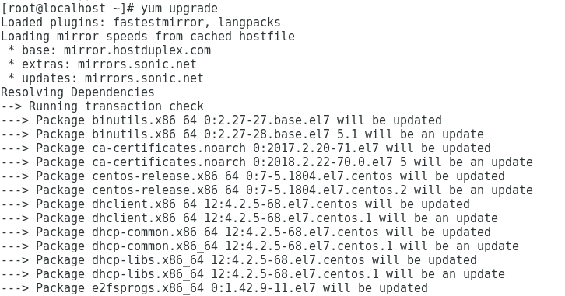

1. **Step 4:**

Install someuseful system utilities that will be required later such as net-tools, curl, ifconfig, wget

# *yum install nano bash-completion net-tools wget curl lsof*

1. **Step 5:**

We can start disabling and removing pre installed unwanted services. To get the list of services we used following command.

*# netstat -tulpn ## To output numerical service sockets  
# netstat -tulp ## To output literal service sockets*

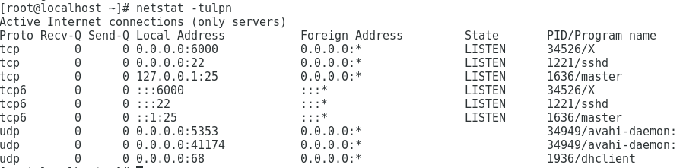

1. **Step 6:**

**Postfix** is started on port 25. **Avahi** daemon binds on all network interfaces and **Chronyd** service binds on all local host and all network interfaces on different ports.

First we removed Postfix MTA services as follows and then proceeded with removal of **Chronyd**

*# systemctl stop postfix  
# yum remove postfix*

*# systemctl stop chronyd  
# yum remove chrony*

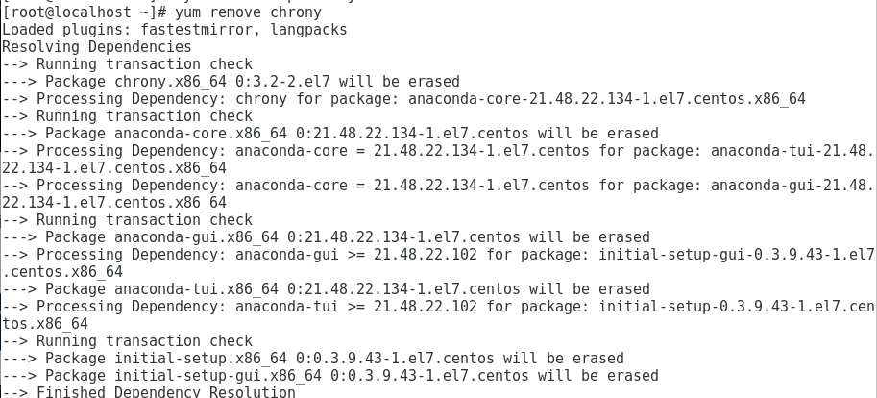

1. **Step 7:**

Set u name for system by using following command

*# hostnamectl set-hostname FQDN_system_name  
# hostnamectl status*

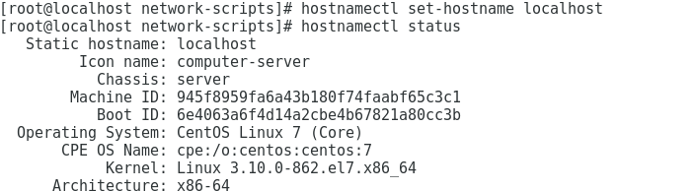

1. **Step 8:**

Next step is to disable the postfix, NetworkManager and firewalld services as follows.

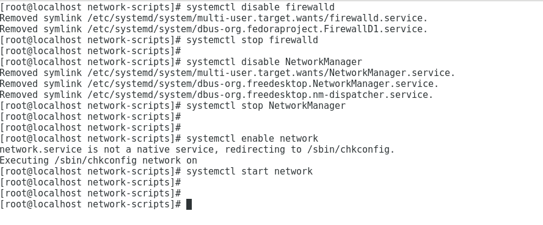

1. **Step 9:**

Install **OpenStack queens** repositories and do a yum install.

*# yum install -y centos-openstack-queens*

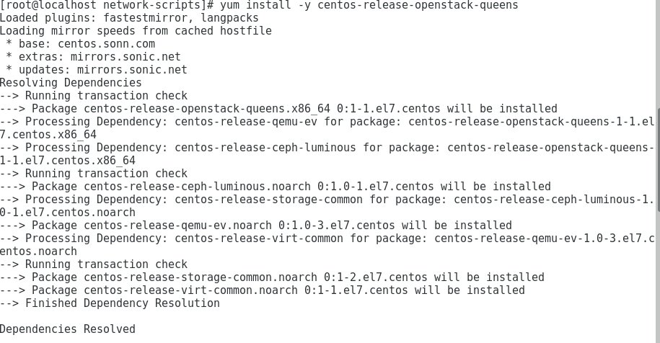

*# yum update -y*

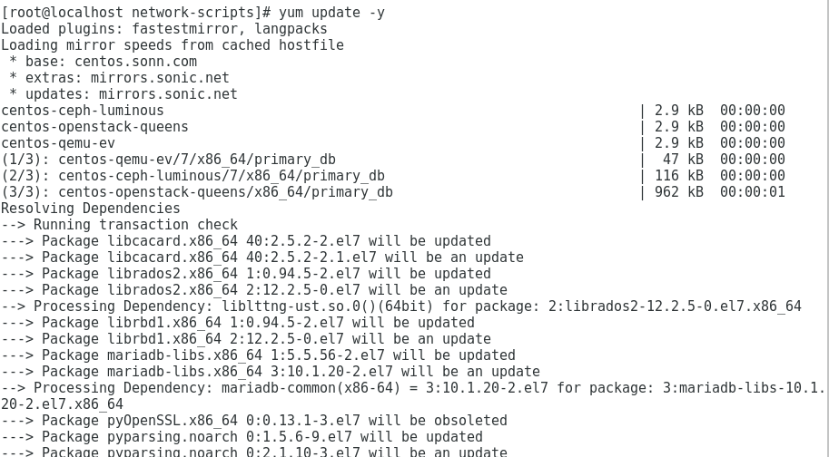

1. **Step 10:**

We installed **Packstack**. Packstack is the utility that facilitates deployment of multiple nodes for different components of **OpenStack** via SSH

*# yum install openstack-packstack*

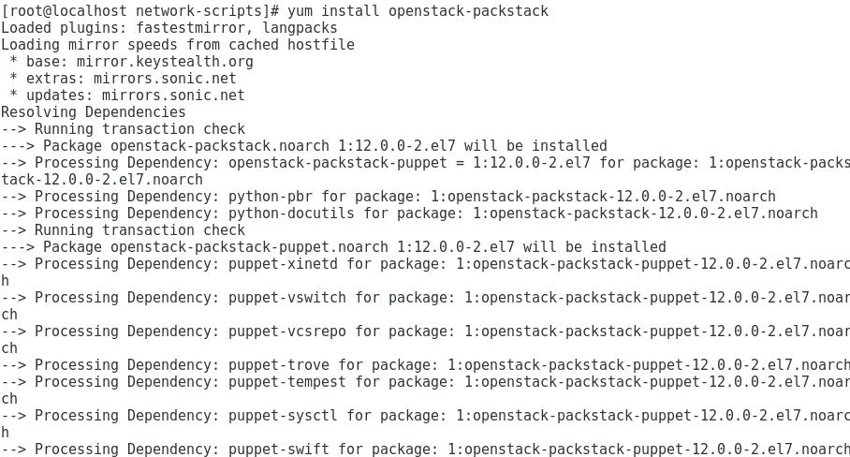

*# yum update -y*

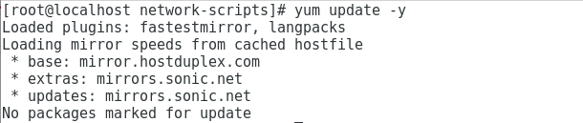

1. **Step 11:**

We can install OpenStack using the Packstack installation file.

*# packstack --allinone*

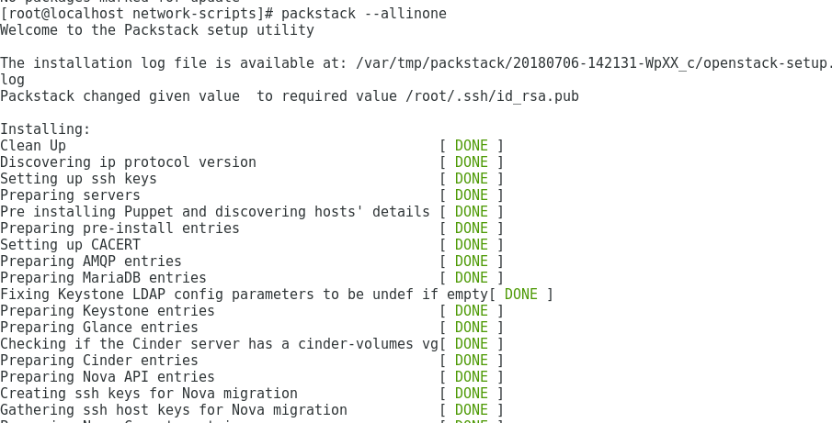

As we can see from the screenshot it allinone command installs everything itself. This saves us from installing individual components separately.

1. **Step 12:**

Next steps are to remotely access the OpenStack Dashboard.

*# https://192.168.1.40/dashboard*

